SCHOOL LEAVERS 2026

IMPORTANT INFORMATION – PLEASE READ BEFORE ORDERING
- Minimum Order Quantity: A minimum of 10 garments is required.
Orders of fewer than 10 will incur a £10 + VAT surcharge.
- Name Accuracy: Please provide names exactly as you’d like them to appear on the garment, ensuring correct spelling and capitalisation.
- Special Range: Our Leavers' Garments are part of a special collection and differ from our core uniform range. Please refer to the sizing guides below when selecting sizes.
- Adult Size Hoodies: These include drawstrings.
- Design Edits: You are entitled to two free edits of your leaver's design. Additional changes will be charged at £10 + VAT per edit.
- Submitting Your Order: Once completed, please email your form to: enquiries@schooltrends.co.uk

CONTACT DETAILS

Your Name
School Name and Address
School Name and Address |  | Postcode
Contact Number
Email Address

STEP ONE: Submit Your List of Names
Please compile the list of first names you would like included in your Leavers' garment design.
- Send the list in a separate Word document.
- If there are duplicate first names, you may include the first name and initial (e.g. Emily S., Emily W.).
- We cannot accept scanned documents, handwritten lists, or copies of class registers.
Please sign below to confirm that, to the best of your knowledge, the names provided are exactly as you would like them to appear in the final design (including correct spelling, capitalisation, and use of nicknames).

⚠️ Important: You are entitled to two free edits. After this, a £10 + VAT fee will apply per additional change. Edits may also result in a longer turnaround time.

Please note: While we do our best to keep the names in order, some repositioning may occur due to space limitations within the design.

Print Name:........................................................... Signature:......................................................................


STEP TWO: Select your chosen design

LEAVERS 2026 DESIGNS

Blank designs available to save you time — perfect for pupil signatures or last-minute orders. |  |  | Traditional Leavers' designs with your Leavers’ Names  Please note that names may need to be repeated or repositioned to ensure a good fit. Where possible, this will be done evenly.
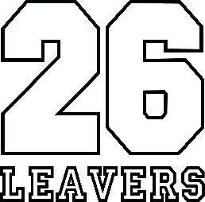 | 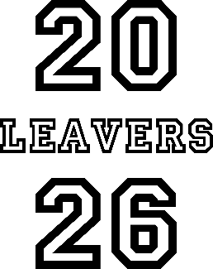 | 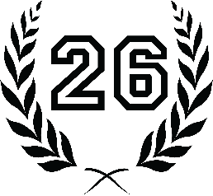 | 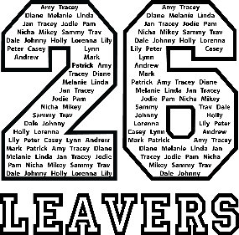 | 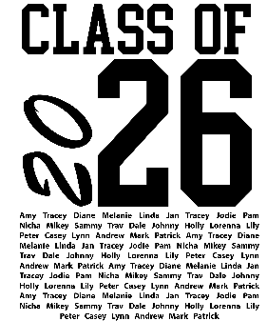 |  | 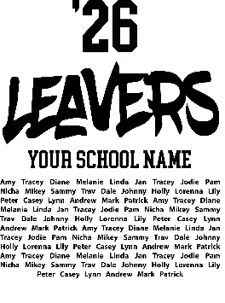
LD1 | LD2 | LD3 | LD1 names | LD4 names |  | LD5 names
LD1 Left Chest | LD2 Left Chest | LD3 Left Chest | £1.30 |  | Where the school logo is on the left chest, the printed Leavers' logo will be placed on the right chest.

Leavers ‘26 at ‘25 prices.
Prices held until 1st September 2025

EXTRAS: Do you require your school logo?

 | Price | Required?
School Logo Left Chest | £1.30
All prices exclude VAT. VAT will be applied where appropriate.

STEP THREE: Select your chosen back print colour:
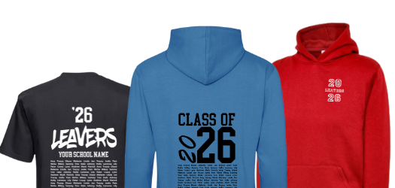
If you select Black, Bottle, Charcoal or Navy garments, a white print will be used to ensure the design is clearly visible.
Black

White

STEP FOUR: Choose your leavers’ garments, you can mix styles, sizes and colours.

THE LEAVERS HOODIE
  Black |   Bottle |   Charcoal |   Navy
  Heather Grey |   Pink | 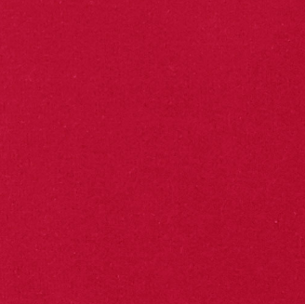  Red | 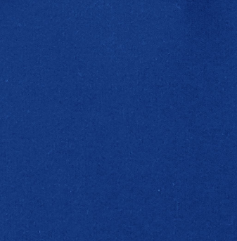  Royal
  Hot Pink |   Orange |   Sapphire Blue |   Kelly Green

Blank design –
No Names
CHILD | £17.50
ADULT | £19.50*

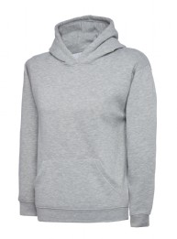

Design with names
CHILD | £19.00
ADULT | £21.00*

Hoodie and Sweatshirt size chart – For a relaxed fit order the next size up!

 | Child  3-4 | Child  5-6 | Child  7-8 | Child  9-10 | Child  11-13 | Adult  XS | Adult  S | Adult  M | Adult  L | Adult  XL | Adult  XXL
Chest to Fit | 24-26” | 26-28” | 28-30” | 30-32” | 32-34” | 36-38” | 38-40” | 40-42” | 42-44” | 44-46” | 46-48”

THE LEAVERS T-SHIRT
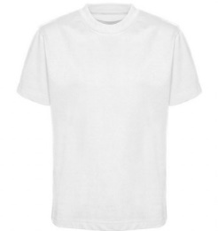

Blank design –
No Names
CHILD | £11.50
ADULT | £12.50*
Design with names
CHILD | £13.00
ADULT | £15.00*
  Navy |   White | Black

T-shirt size chart
 | Child  3-4 | Child  4-5 | Child  5-6 | Child  6-7 | Child  7-8 | Child  9-10 | Child 11-12 | Adult XS | Adult  S | Adult M | Adult  L | Adult XL
Chest to Fit | 22” | 24” | 26” | 28” | 30” | 32” | 34” | 36” | 38” | 40” | 42” | 44”

*All prices exclude VAT. VAT will be applied where applicable.

STEP FOUR: Choose your leavers' garments, sizes and colours.

Garment Type | Colour | Size | Quantity
Hoodie | Pink | S | 10
Please remember to consider your chosen design and back print colour. You can mix garment styles, sizes and colours.

PLEASE EMAIL THIS COMPLETED FORM TO ENQUIRIES@SCHOOLTRENDS.CO.UK

OTHER INFORMATION:

- Once we receive your completed form, we may contact you if we have any questions about your submission. Your design will then be created and sent to you for approval.
- It is your responsibility to ensure all names are correct and to return the approval form as quickly as possible. If edits are required, the turnaround per edit is generally 24 hours. Checking the accuracy of names early helps prevent delays.
- If you receive an edited design, you must re-check all names, as edits often require other names to be repositioned.
- Please note: A £10+VAT fee will apply for more than 2 edits to your Leavers' design.

- Once we receive your signed approval form, your order will be delivered within 15 days.

