IMPORTANT INFORMATION:
SCHOOL LEAVERS 2024
- Minimum order is 10 garments. Orders of less than 10 will be subject to a fee of £10+VAT
- Provide the names as you want them to appear, please ensure correct spelling and capitalisation
- The Leavers Hoodie is different in sizing and styling to our Classic Hoodie
- The ‘adult size’ Hoodie has longer arm/body length and will come with draw strings
- You are entitled to two edits to your leavers design before a £10+VAT fee is applied per change
- Please email the completed form to info@schooltrends.co.uk

CONTACT DETAILS

Your Name
School Name and Address
Postcode
Contact Number
Email Address

STEP ONE: Please compile the list of names which you would like on your leavers garments Please send your list of names in a separate word document.
Please note we cannot accept scans, register copies or handwritten names.

Please sign below to agree that, to your best knowledge, the names you have provided to us are exactly as you want them to appear within your Leaver’s design, e.g. first name/surname order, nicknames, capitalisation, spelled correctly etc. Please be aware that you are only entitled to two edits before a £10+VAT fee is applied per change and all edits will result in a longer turnaround time on your order.

Print Name:........................................................... Signature:......................................................................

STEP TWO: Select your chosen design

LEAVERS 2024 DESIGNS -

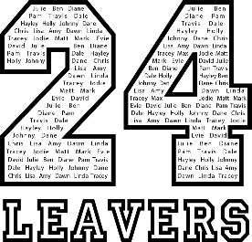 | 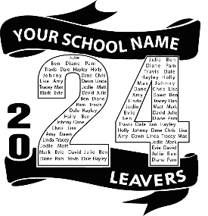 | 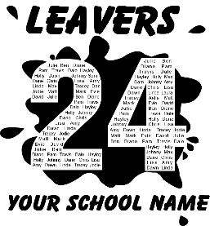 | 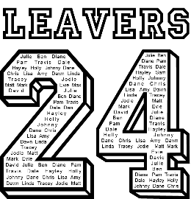 | 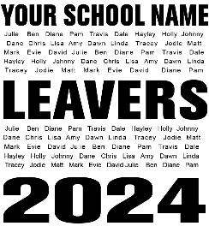
LD1 names | LD2 | LD3 | LD4 names | LD5
LD1 blank | Blank for your pupils to sign at school or for late orders |  | LD4 blank
Please note that names may need to be repeated to ensure a good fit. Where possible this will be done evenly.

EXTRAS: Do you require your school logo?

 | Price | Required?
School Logo Left Chest | £2.00
All prices exclude VAT.
VAT will be applied where appropriate.

STEP THREE: Select your chosen back print colour:
If you select Black, Bottle, Charcoal or Navy coloured garments then we will apply a white print to ensure the print is visible.
Black

White

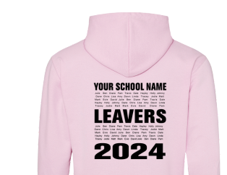

STEP FOUR: Choose your leavers garments, you can mix styles, sizes and colours.

PLEASE NOTE – SIZING IS DIFFERENT TO PREVIOUS LEAVERS ITEMS

THE LEAVERS HOODIE THE LEAVERS SWEATSHIRT

CHILD | £13.75
ADULT | £16.00
CHILD | £17.00
ADULT | £19.00

Black | Bottle | Charcoal | Navy
Heather Grey | Pink | Red | Royal

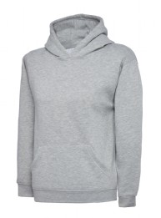
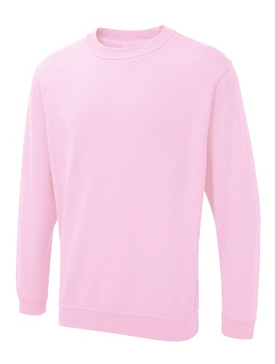

Hoodie and Sweatshirt size chart

 | Child  3-4 | Child  5-6 | Child  7-8 | Child  9-10 | Child  11-13 | Adult  XS | Adult  S | Adult  M | Adult  L | Adult  XL | Adult  XXL
Chest to Fit | 24-26” | 26-28” | 28-30” | 30-32” | 32-34” | 36-38” | 38-40” | 40-42” | 42-44” | 44-46” | 46-48”

THE LEAVERS T-SHIRT
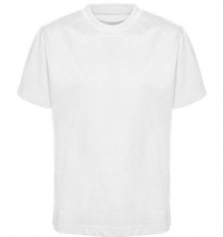

CHILD | £10.75
ADULT | £11.75
Navy | White

T-shirt size chart
 | Child  3-4 | Child  4-5 | Child  5-6 | Child  6-7 | Child  7-8 | Child  9-10 | Child 11-12 | Adult XS | Adult  S | Adult M | Adult  L | Adult XL
Chest to Fit | 22” | 24” | 26” | 28” | 30” | 32” | 34” | 36” | 38” | 40” | 42” | 44”

All prices exclude VAT. VAT will be applied where applicable.
All prices exclude VAT. VAT will be applied if appropriate.

STEP FOUR: Choose your leavers garments, sizes and colours.

Garment Type | Colour | Size | Quantity
Hoodie | Pink | S | 10
Please remember to consider your chosen design and back print colour. You can mix garment styles, sizes and colours.

PLEASE EMAIL THIS COMPLETED FORM TO INFO@SCHOOLTRENDS.CO.UK

OTHER INFORMATION:

- Upon receipt of the completed form, we may contact you if we have any queries regarding your submission. We will then produce your design within 7 working days and send it to you for approval.
- It is your responsibility to check that all names are correct, and to return the approval form back to us as quickly as possible. Should the design require any edits the turnaround per edit is generally 7 working days, so accuracy of names is key to avoid delays on your order.
- When you receive an edited design for approval you will need to re-check all names again as edits generally require other names to be moved around.
- Please note a £10+VAT fee will be applied for more than 2 edits to your leavers design.

- Once the approval form is received by us your order will be delivered within 21 days.

