Packed Per Pupil (PPP)
Ordering Guide

- Login – go to www.schooltrends.co.uk and login
- Navigation options
- My orders – shows all previous orders
- My details – manage schools contact details
- School Order – place a bulk school order
- PPP Order – place a Packed Per Pupil (PPP) order
- Un-collated orders – stored uncollated PPP orders waiting to be collated and sent to School Trends

- Placing a School order – click on ‘School Order’, add products to your basket and follow the checkout procedure

- Placing a PPP order – click on ‘PPP Order’
- Input product quantities per pupil order
- Click ‘ADD TO BASKET’ or if you would like to add a PE Kit to your order, select ‘ADD TO BASKET & SELECT PE KIT BUNDLE’

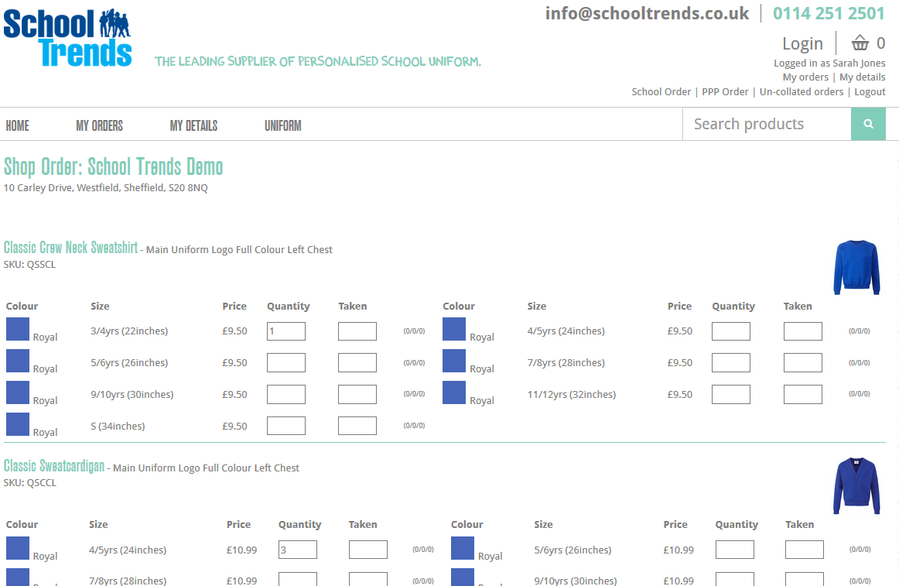
- Select ‘PPP Delivery’
- Press ‘CHECKOUT’
- Enter pupils Name and Class, & press ‘NEXT’

- Review the order and click ‘PLACE ORDER’
- Repeat this process for each Pupil order

- Collating Orders and sending to School Trends
- Click on ‘Un-collated Orders’
- Select the order(s) to collate and press ‘COLLATE ORDERS’ – this will send the order(s) to School Trends
Note: You also have the option to cancel orders
Note: You must collate your orders after you have placed them

