NURSERY GRADUATES 2026
CONTACT DETAILS
Your Name
School Name and Address
School Name and Address |  | Postcode
Contact Number
Email Address

2026 GRADUATE T-SHIRTS - £8.25 each including one Design
Select your design
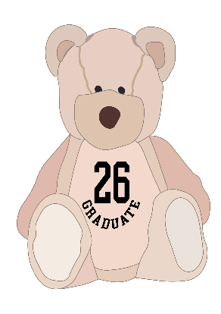 | 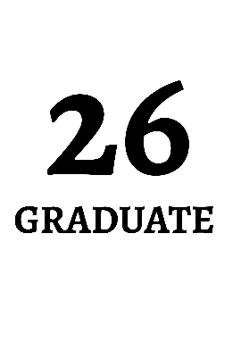 |  |  | 
Design 1 € | Design 2 € | Design 3 € | Design 4 € | Design 5 €

EXTRAS
Would you like your:
Graduate Design |  | School name under the design? | Nursery logo on the left chest?
Front | Back | £1 per t-shirt | £1.55 per t-shirt
€ | € | € | €

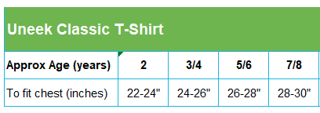
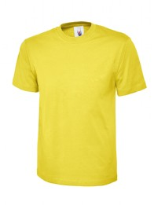

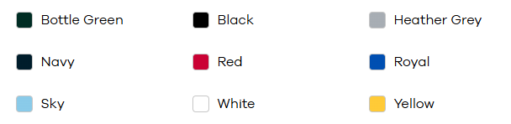

Colour | Size | Qty
White | 3/4 yr | 6

PLEASE EMAIL THIS COMPLETED FORM TO ENQUIRIES@SCHOOLTRENDS.CO.UK

